Azure Databricks Coding Challenge (10-12-2024)

Done by: S.YAZHINI

1. Create a cluster & Attach the notebook to the cluster and run all commands in the notebook & creates a DataFrame from a Databricks dataset& Create a Visualizations in Databricks notebooks

**Cluster created:**

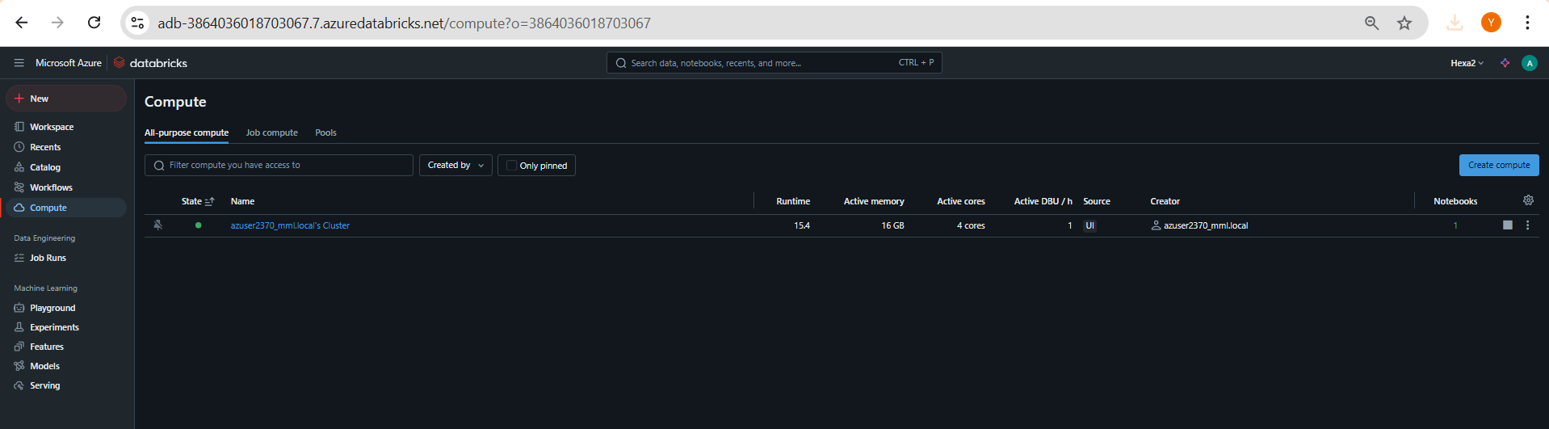

**Databricks Workspace Created:**

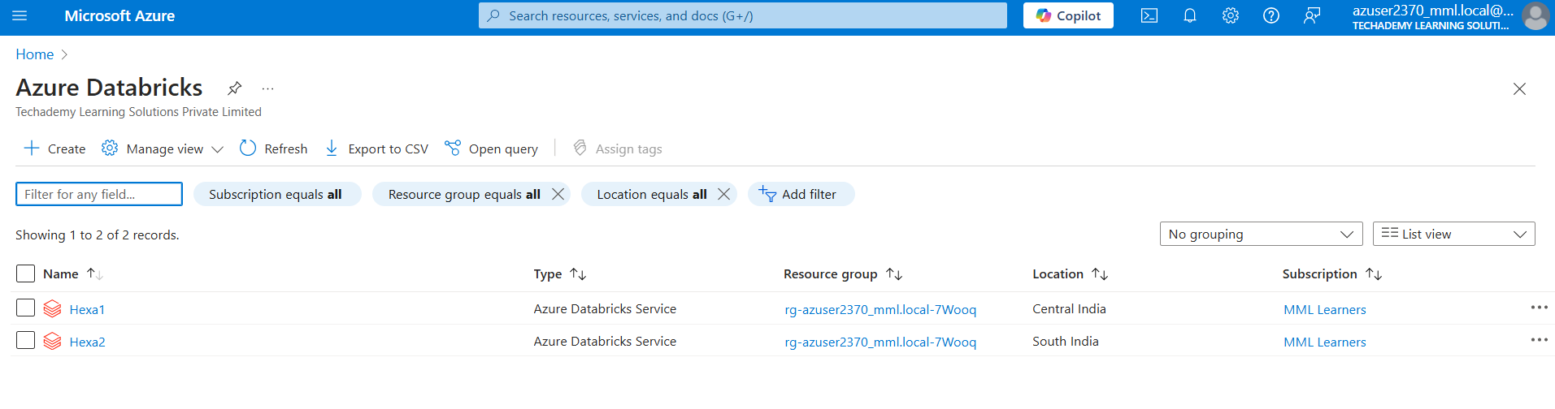

**Datasets added to the Databricks Catalog (inside hive metastore):**

Dataset used (from Kaggle):

<https://www.kaggle.com/datasets/shivamb/netflix-shows>

You can also download the above dataset from my drive link given below:

<https://drive.google.com/file/d/1ZmKmbjTEWCF89IiwGBsF3xRWKR_sA58l/view?usp=drive_link>

Here are the uploaded dataset steps screenshots:

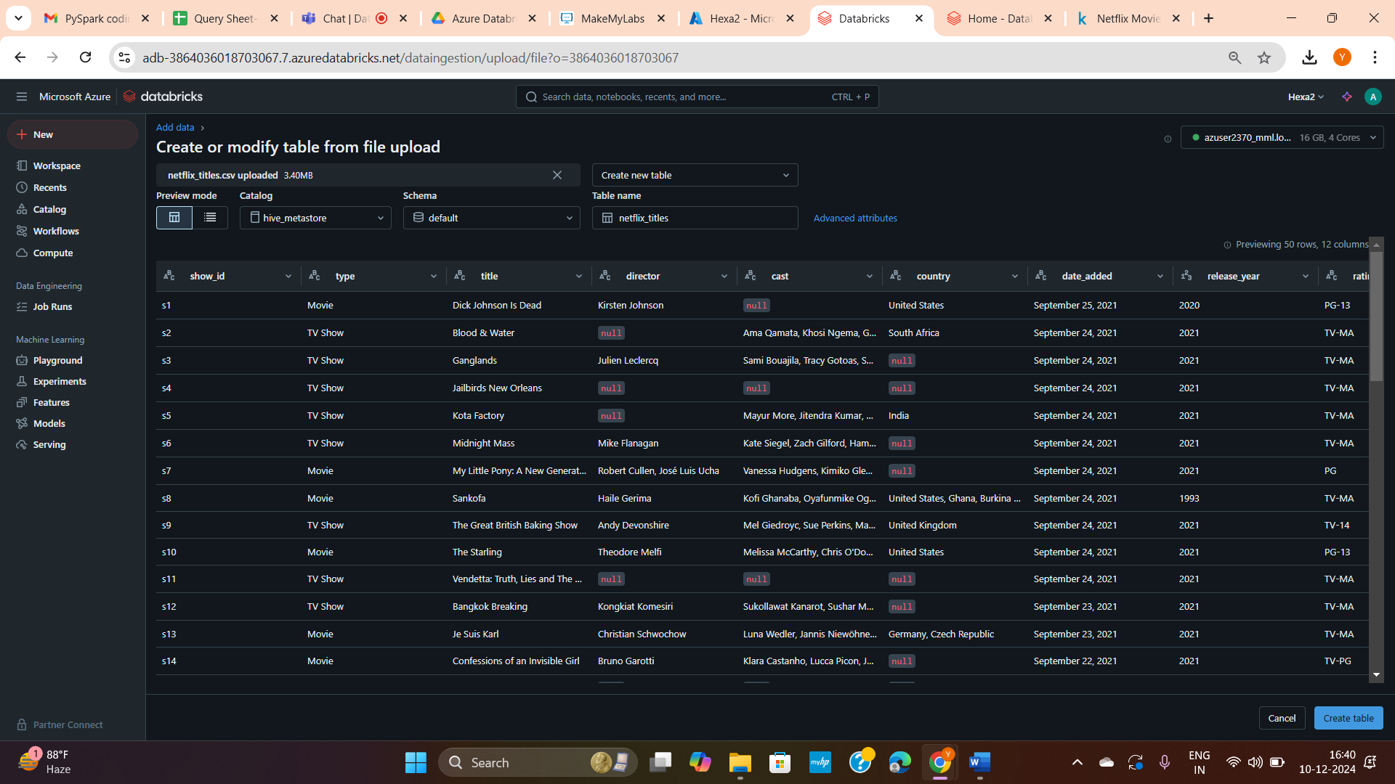

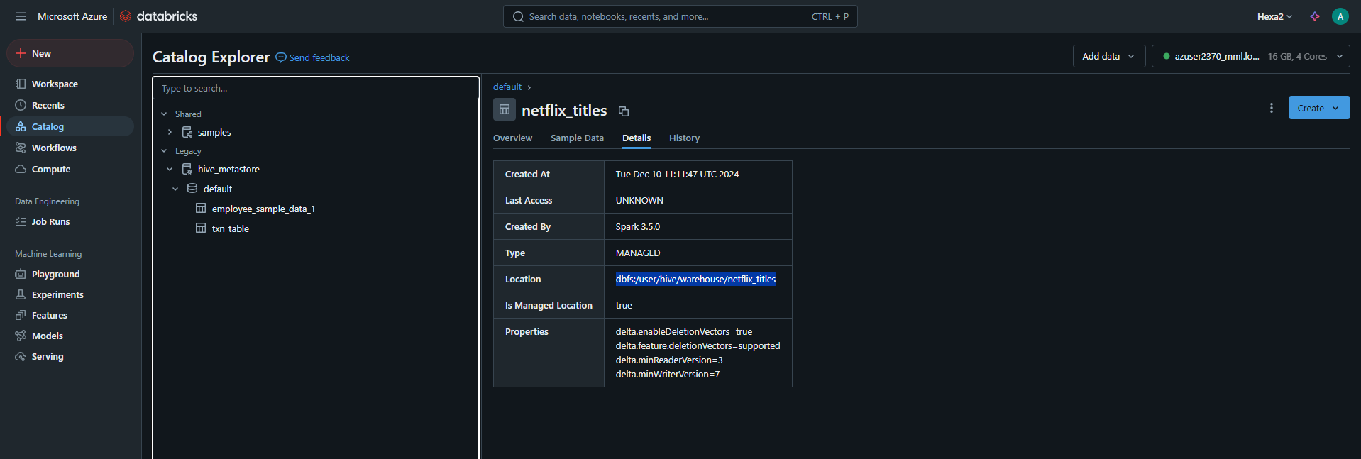

**Notebook attached to the cluster:**



**PySpark Code/commands:**

**Initialize Spark Session:**

from pyspark.sql import SparkSession

from pyspark.sql.functions import col, lit, to_date

# Initialize Spark Session

spark = SparkSession.builder.appName("Netflix_ETL").getOrCreate()

where Netflix_ETL is a general app name given by me.

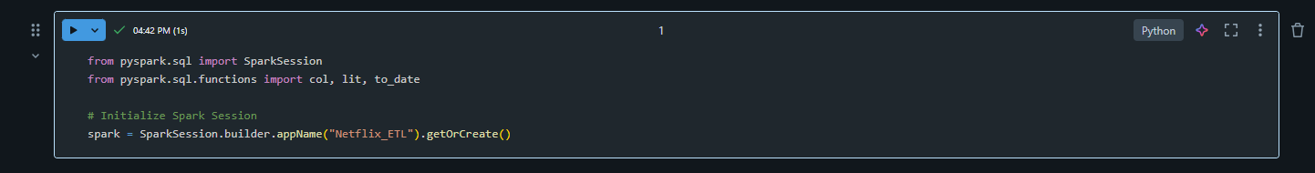

**Command to check whether our table is available in the desired directory:**

Syntax: dbutils.fs.ls("dbfs:/directory_path")

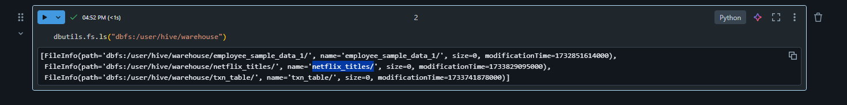

**Ingestion: Load data into DataFrame**

# Load data into DataFrame

file_path = "dbfs:/user/hive/warehouse/netflix_titles"

# Load the Delta Table into a DataFrame

df = spark.read.format("delta").load(file_path)

# Show the first few rows

df.show(10)

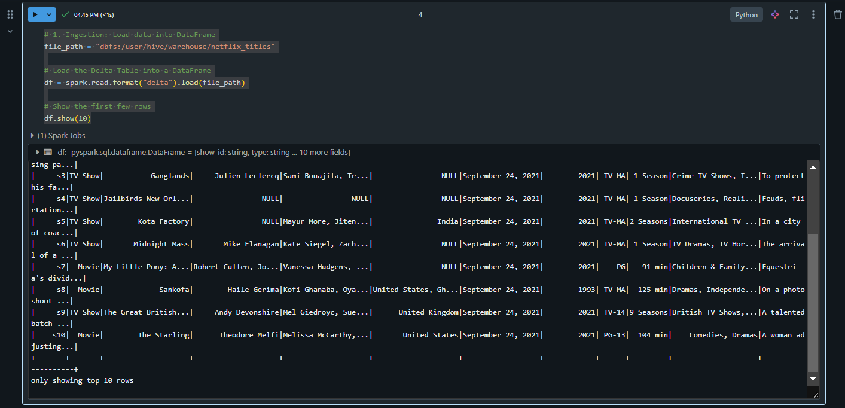

**For displaying schema of our delta table:**

Syntax: df.printSchema()

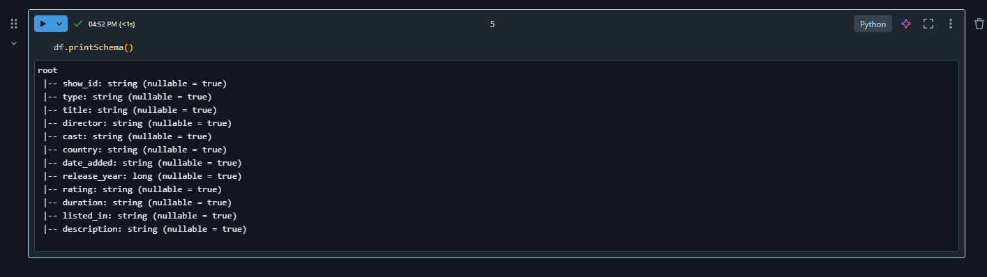

**Transformation: Data Cleaning and Filtering codes:**

**Replace nulls in 'director' column with 'Unknown'**

df_cleaned = df.fillna({"director": "Unknown"})

**Filter movies released after 2010**

df_filtered = df_cleaned.filter(col("release_year") > 2010)

df_filtered.show(10)

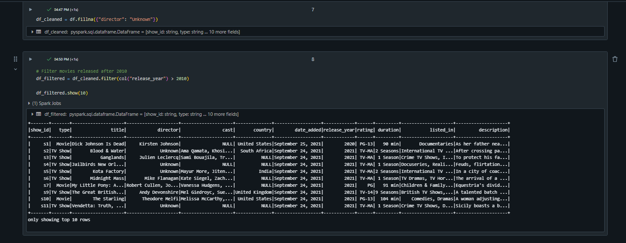

**# Extract only required columns**

df_transformed = df_filtered.select("title", "director", "release_year", "type", "country")

df_transformed.show(10)

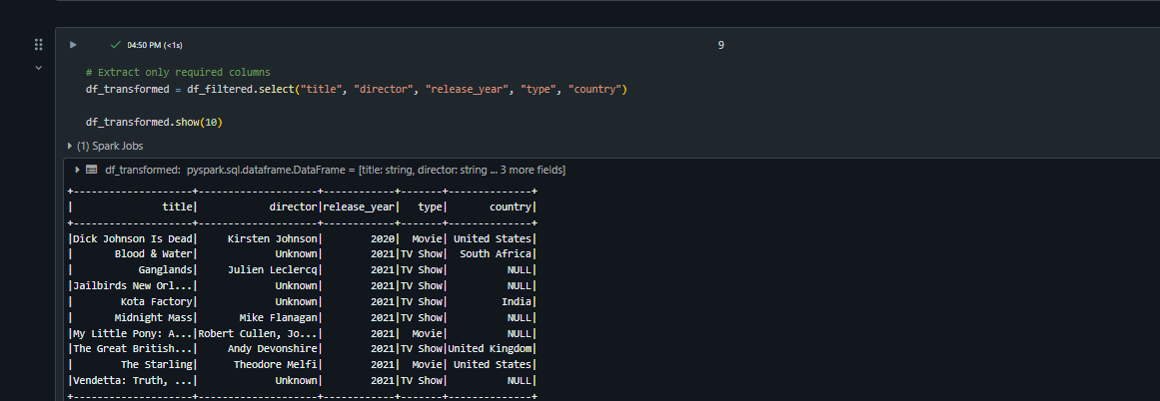

**Getting data with a specific condition:**

from pyspark.sql.functions import when, col

# Add a column to categorize content as "New" or "Old"

df_categorized = df_transformed.withColumn(

    "content_age",

    when(col("release_year") > 2015, "New").otherwise("Old")

)

df_categorized.show(10)

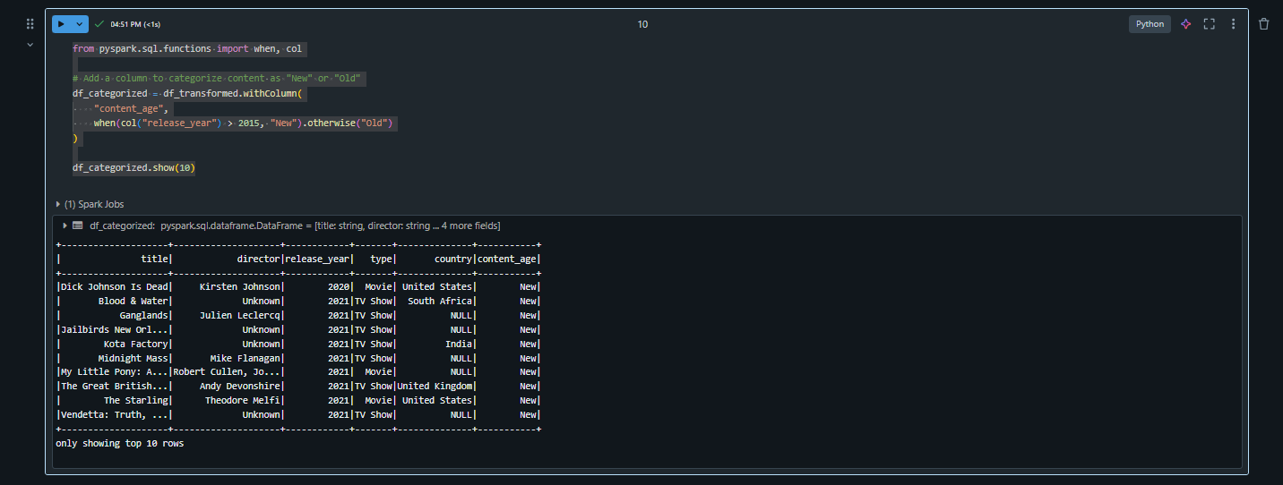

**Visualization:**

X-axis (sample): release_year

Y-axis (sample): count(title)

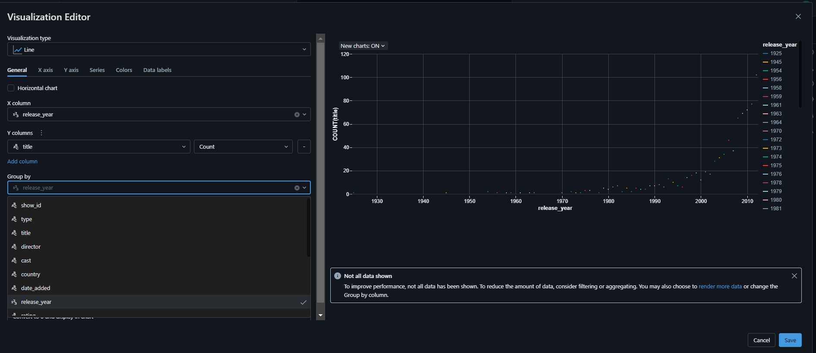

**Data Profile:**



